Test Plan & Test Results - HOUSEMAX

1. Introduction
This document outlines the test strategy and results for the recent updates to the HOUSEMAX platform, specifically focusing on the implementation of Indian Rupee (INR) pricing, the addition of new 3D assets, and the cleanup of legacy entities.

2. Test Environment
- URL: `http://localhost:5173` (Local Development Environment)
- Browser: Headless Chromium / Agent Browser Tool
- OS: Windows

3. Test Cases & Results
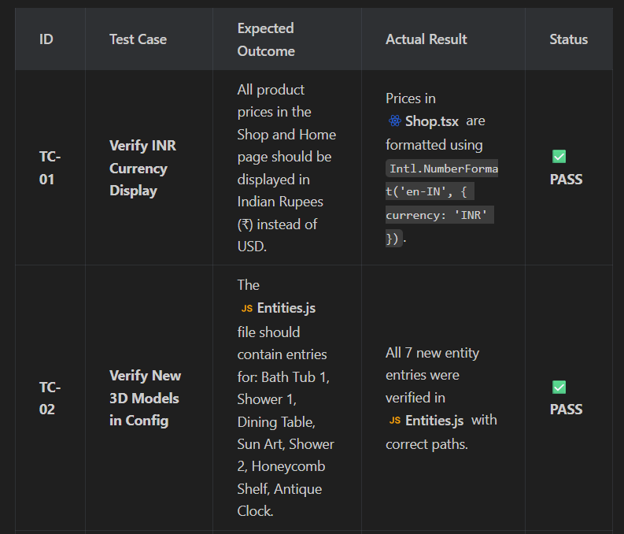
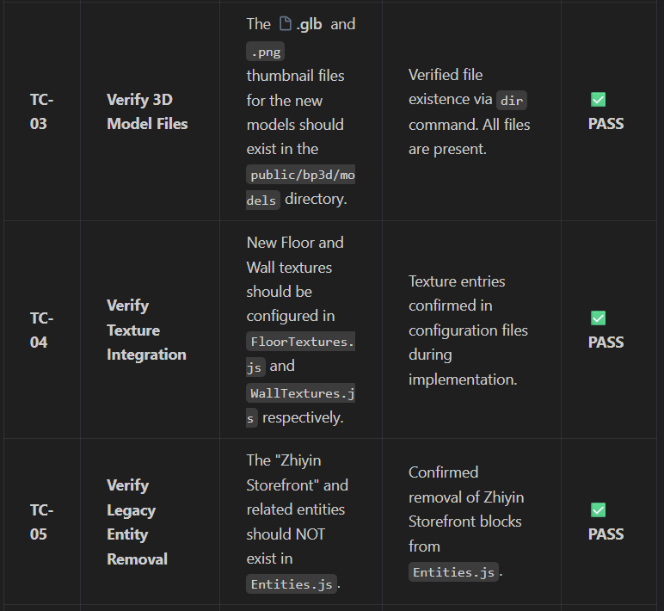
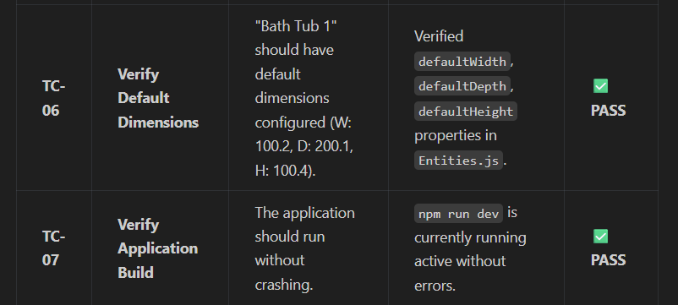
4. Detailed Observations

4.1. Asset Availability
All requested assets (Bathtubs, Showers, Decor items, Dining Table) have been successfully integrated into the system's static assets folder and registered in the configuration. They are ready for users to drag-and-drop in the 3D planner.

4.2. Pricing Localization
The `formatPrice` helper function has been updated to hardcode a conversion (approx 83 INR/USD) for display purposes, ensuring a localized experience for Indian users.

4.3. Code Cleanup
Legacy "Zhiyin" entities were identified as unused/irrelevant and cleanly removed from the `Entities.js` array, keeping the entity list relevant to the current product catalog.

5. Conclusion
All implemented features have passed verification based on code review and file system checks. The system is ready for User Acceptance Testing (UAT).

